Skyscanner Flights Mobile App Usability Evaluation Report

|  |  |
| --- | --- |
| Prepared for: | Philip Carter |
| Prepared by: | Mao Chuan Li |
| Student ID: | 14854389 |
| Submit Date: | 2015/08/21 |
| Paper Name: | Usage Centred Design |
| Paper Number: | 408204 |
|  |  |

# Executive Summary

This reports provides a usability analysis of a mobile app called “Skyscanner Flights” published by one of the world leading flights search engine – Skyscanner. For evaluation of the mobile app, the situated co-inquiry method suggested by Carter (2007) is utilized to conduct the usability tests. Four international students and one housewife are requested to execute only one task for booking a round trip flight from Auckland to either China or India. Overall 5 testers could easily and smoothly operate the app based on their previous experiences. 7 dominant positive features and 3 ‘hidden’ surprising features have been identified. On the other hand, 8 flaws of the app were identified which will surely damage the users experiences.

Of all the negative aspects, failure to remind end users the app’s scope and goal is the most critical. Because every user expects to book the flights directly from within the app and takes it granted as the app’s built-in functionality, so the users got extremely frustrated and even angry with the app when they were taken to a third party website. They even did not realize that they were booking on another website, so all the bad experiences were blamed on the app.

A recommendation for the above issue among others were given at the end of the report. With those recommendations, hopefully the end users could have a better user experiences and book flights more smoothly and efficiently with Skyscanner.

For time and resource limitation, only one type of users is evaluated in this report – all of them have computer skills and have a smart phone, and they all have had used similar apps or websites before.

Contents

Executive Summary 2

1 Introduction 1

2 Methodology 1

2.1 Users Selection 2

2.2 Test Process 2

3 Findings 2

3.1 Positive Aspects 2

3.2 Negative Aspects 4

4 Recommendations 5

4.1 Explicit Indication of the App’s Scope 5

4.2 Add Price to Dates 5

4.3 Show Remaining Tickets Information 5

4.4 Rename or Move the “Explore” Button 5

4.5 Get Location even without GPS 5

4.6 Add Currency Label and GST to the Price Label 6

5 Conclusion 6

5.1 Other types of Users 6

5.2 Lesson Learned 7

5.3 Next Steps 7

6 References 7

7 Appendices 8

7.1 The logger scripts 8

7.2 The App’s Screen Snapshots 10

# Introduction

With the advance of mobile devices hardware and the wider coverage of modern mobile network, mobile phones have played an important roles in our daily life and business. Mobile computing is pervasive around the world, every organization is trying to expand their businesses with a mobile app. Skyscanner is one of the world leading flights search engine, providing the lowest price information to travellers around the globe for free. As the other service providers, they have developed their own mobile app “Skyscanner Flights”, and published it to the 2 most famous app store: Google Play and Apple Store.

This project is to evaluate the usability of this mobile app, and find the most appealing features as well as the negative aspects of it. Section 2 demonstrates how the evaluation tests are conducted; section 3 listed all the positive and negative features of the app; section 4 gives out a few recommendations corresponding to the negative aspects; section 5 shows some future work needed be done to complete the evaluation.

# Methodology

The situated co-inquiry method suggested by Carter (2007) is used to conduct the tests. As the figure 1 shows, the users are holding the mobile phones operating the Skyscanner app and talking loud about what he or she thinks, while the facilitator is sitting beside the user and monitors the operations and communicates with both user and the logger. The logger is sitting in opposite of the users and observe the situation, and logs all important signs, facial and verbal expressions.

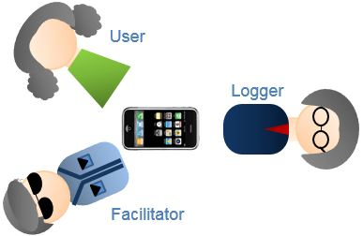

Figure 1 Situated Co-inquiry

## Users Selection

In total, 4 international students from AUT and 1 housewife were requested to conduct the tests. All of them are familiar with computers and have had long experiences with smart phone apps. None of them has used the Skyscanner app before, but all of them have used other apps or experienced making phone calls to airlines to book tickets.

## Test Process

The test venue is located in the postgraduate lounge and in the housewife’s home. At first, before starting the official test on the mobile app, a brief introduction of the test is given to the users and an interview on the experience of flights booking has been conducted. After that a simple task is given to the user: **Book round trip flights from Auckland to home town.** After the user finished the task or decided to stop testing, a survey about the good and bad of the app is collected.

# Findings

## Positive Aspects

### UI Interface

The UI interface is very beautiful, friendly and professional, consistent with the company’s logo theme. All UI elements are around the alight blue colour. The colour assortment is reasonable and bright, giving users a comfortable feeling.

### Login/Registration Window

The login/registration screen supports both Facebook and Google (only supported on Android) third party authentication. This greatly simplified users’ registration process, according with users’ customary practices. See appendix 7.2.1.

### Passenger Selection Window

The passenger’s selection is very intuitive and descriptive. Definitely a good plus for this application. See appendix 7.2.5.

### Departure and Return Date Selection

The department and return date selection is intuitive, even it has an animation hint on the top to ask users to select an return date after selecting a department date; All the dates between the 2 dates are highlighted to indicate the duration, giving end users a very direct visual demonstration of the journey; See appendix 7.2.7.

### Default Values

The default values for flight selection match most of the users’ requirements, like the cabin class, set with economy and stop option set with “Direct Only off”. The flights shown in the search result are shown in price ascending order by default.

### Airport Selection

The airport selection is very quick and accurate, the matching results are shown when the first character is entered. Both city’s name and airport’s code are supported very well, even the Chinese character for a city is well recognised. See appendix 7.2.7.

### Lovely Progress Bar

The animated progress bar is very interesting when the application search the flights. The users enjoyed seeing the ‘plane’ flying from the left side of the window to the right side, instead of getting boring and impatient. See appendix 7.2.1.

### ‘Hidden Features’

The hidden features are very helpful to experienced users if given a little more time to explore the application. These features are overlooked by all testers except the housewife. See appendix 7.2.6.

#### Explore the Globe

The explore button will show users an earth model with airports and the lowest prices for a flight. The earth could be dynamically rolled. For those flexible travellers, this global could help them have an overview of the available airports and the possible lowest prices in any position on the earth;

#### Price Bar Charts

The bar charts give users a general view of the prices curve around a period. For those flexible users, they can dynamically change their travelling date to find a lowest price within a time period.

## Negative Aspects

### Failure to Remind Users of the App’s Scope and Goal

The most important hint information is located at the bottom of the screen, or shown on a splash screen for a short time, all users just ignored that and led confusion and discomfort for end users. In the end, all users blame the poor user experiences of the third parties websites on the Skyscanner app. See appendix 7.2.1 and 7.2.2.

### Inconsistency between Different Portals

The service provider Skyscanner has 3 different portals for end users - website, mobile app for iPhone/iPad, and Android devices; the user interfaces for iPhone and Android devices are almost different, this might cause troubles for end users when they switch from one to another. See appendix 7.2.3 and 7.2.4.

### Location Service Not Working Well

The mobile app will first pops up a dialog to ask permission to access the location service on the device, if users reject to grant it, the app will either choose United States (Android) or New Zealand (iPhone) as the default departure location. This will slightly hurt the users’ experience of using the app. But even without location service access of the phone, the app still could manage to get the location of the device by the wifi-network, which can be used to search in a global database to locate the phone’s position (Anonymous 2015). See appendix 7.2.4.

### Vague Price Label

The price for the flights is not clearly indicative for the currency and the tax information is not shown for users’ awareness. Users cannot tell if the price is for New Zealand dollars or US dollars. See appendix 7.2.8.

### Lack of Multiple Languages Support

Not as the website, there are multiple versions of websites for different countries and different languages, the app only supports English, and for those not proficient in English, multiple languages support is very much desirable.

### Confusing When No Search Results

When there is no search result, the display is very confusing. Most of the testers were confused when seeing this page. See appendix 7.2.8.

### Too late to respond the click “Clear Filter”

When clicking the “Clear Filter” button, the response time is too long so that users felt frustrated and impatient with the app. See appendix 7.2.9.

### “Checking Bags” Hint is bad

When clicking “Checking Bags” hint, the app jumps outside of the app to a website which shows a chunky web page. This is a very bad decision and will cause unnecessary trouble to end users;

# Recommendations

## Explicit Indication of the App’s Scope

The transition window should pause and emphasise that the app only searches for the lowest prices in market, does provide the book service, and warn the users that they will be taken to a third party website for further booking, then asks for end users’ confirmation for windows transition. With this important information, users will get aware that they are leaving the app. All the inconveniences will be linked to the 3rd party websites instead of the Skyscanner app. See appendix 7.2.1 – Snapshot.2.

## Add Price to Dates

The date selection view for both departure and return is very intuitive for users, but if the calendar could show price information there, the users will be more delighted. See appendix 7.2.8.

## Show Remaining Tickets Information

The resulting flights in the list does not show the available tickets information, showing the remaining tickets count will be very helpful for end users. See appendix 7.2.8.

## Rename or Move the “Explore” Button

“Explore” button on iPhone is suggested to rename or be moved somewhere else. In all 5 tests, no one clicked that button, and all wondered what that button is working for. See appendix 7.2.4.

## Get Location even without GPS

When user inputs the flights information, an automatically recognized location of the phone could greatly simplify the users’ input and please the users’ experiences. Without the permission of access the phone’s GPS, the app still can manage to locate the user’s location with the help of wifi-network. See appendix 7.2.4.

## Add Currency Label and GST to the Price Label

The price label should better explicitly illustrate the currency so as to avoid the confusion of users. An USD or NZD label will definitely give the users the most straightforward information. Also a label like “GST Included” or “GST Not Included” will provide further more clear information. See appendix 7.2.8.

# Conclusion

Overall the mobile app “Skyscanner Flights” has given users a great user experiences with its beautifully designed user interfaces and deliberately designed booking process until users click the “Book” button. Skyscanner has done her best to simplify the searching and enriched the app with additional features like the “Explore” and “Price Bar Charts”. But the goal of the app has not been clearly conveyed to the end users, who have expected to book the flights within the app, which is out of scope of the app. Although the app has tried more than once to remind the users of this limitation, but all of the efforts are wasted. An explicit statement of the app’s functionality and confirmation button for heading for the third party website is strongly recommended to fix the issue.

## Other types of Users

As limited by the time and resource, only one type of users is introduced in this evaluation test. There are also other types of end users who are supposed to use the app.

* Elderly or People has Visual Impairment – they are starting to accept smart phones, and might be expecting to use the mobile app in a different way.
* Regular Traveller - they may have different requirements on the mobile app, for example: a price change notification, a built-in calendar support, or a multiple flights management.
* Freelancer Travelling around Globe - there might be some travellers who have no fixed schedules and destinations.

## Lesson Learned

### Atmosphere Creation

For the first 4 international student testers, the setting is in a postgraduate lounge. Although all facilitators, testers and loggers are classmates and familiar with each other, the invisible stress to complete the task seems existing in every case. Every tester wanted to complete the task as soon as possible. Due to their hurry, the ‘hidden features’ have been ignored. In contract, the test with the housewife has taken far longer time than the 4 classmates. All the ‘hidden features’ have been explored.

### Position of the Logger

Loggers at first sit in the opposite of the tester and facilitator, without seeing the screen of the phone, they found it difficulty understand the statements of both facilitator and tester. So they had to stand up again and again to pause the test to ask testers to reproduce the scenarios. At last the logger just sat on the other side of the tester just as facilitator to monitor the operations. Getting more familiar with the app and setting up a synchronous screen might be helpful.

### Logger Needs More Training

As the pictures in appendix 7.1 shows, the handwriting is very difficult to review. The most important task in the situated co-inquiry is put on the logger’s shoulder. To understand the situation and precisely write down the users’ expressions is very difficult for an untrained logger.

## Next Steps

The next steps would be further categorizing the end users and recruit more testers to evaluate the app. In the meantime, we may send the recommendations to Skyscanner to ask for changes of the app and re-evaluate the corresponding features.

# References

Anonymous (2015). "Wi-Fi positioning system." Retrieved August 14, 2015, from   
 https://en.wikipedia.org/wiki/Wi-Fi_positioning_system.

Carter, P. (2007). "Liberating usability testing." interactions **14**(2): 18-22.

# (Carter 2007)Appendices

## The logger scripts

There are about 10 pages of papers used to log the testing process. Two example logging papers are listed here:

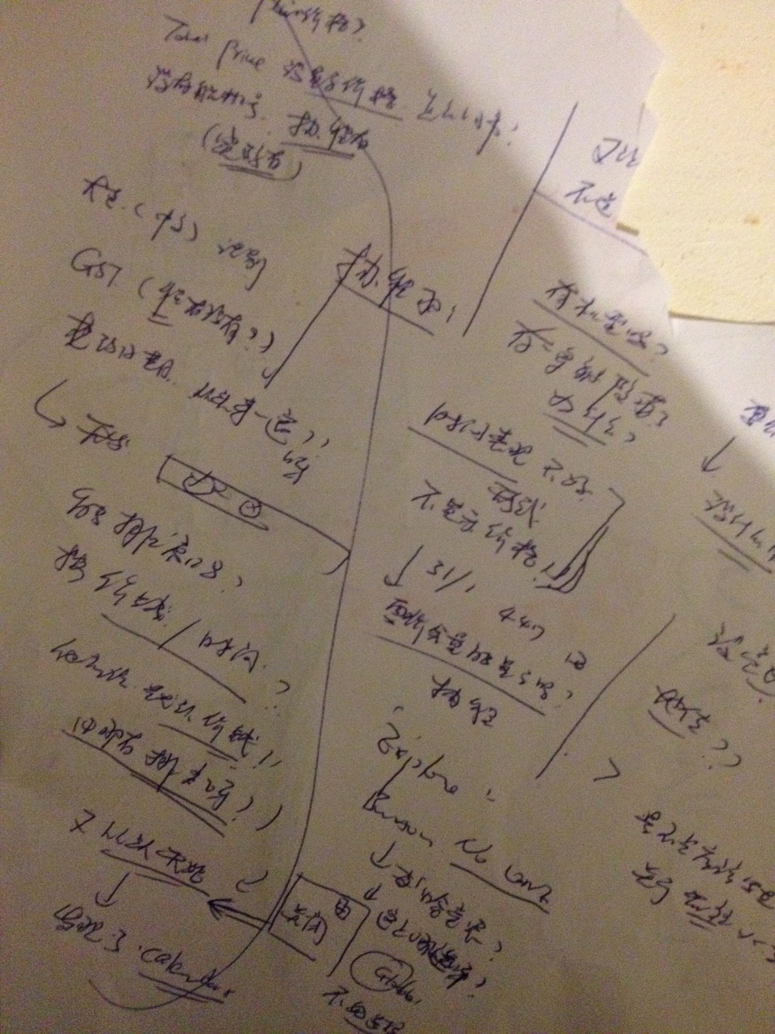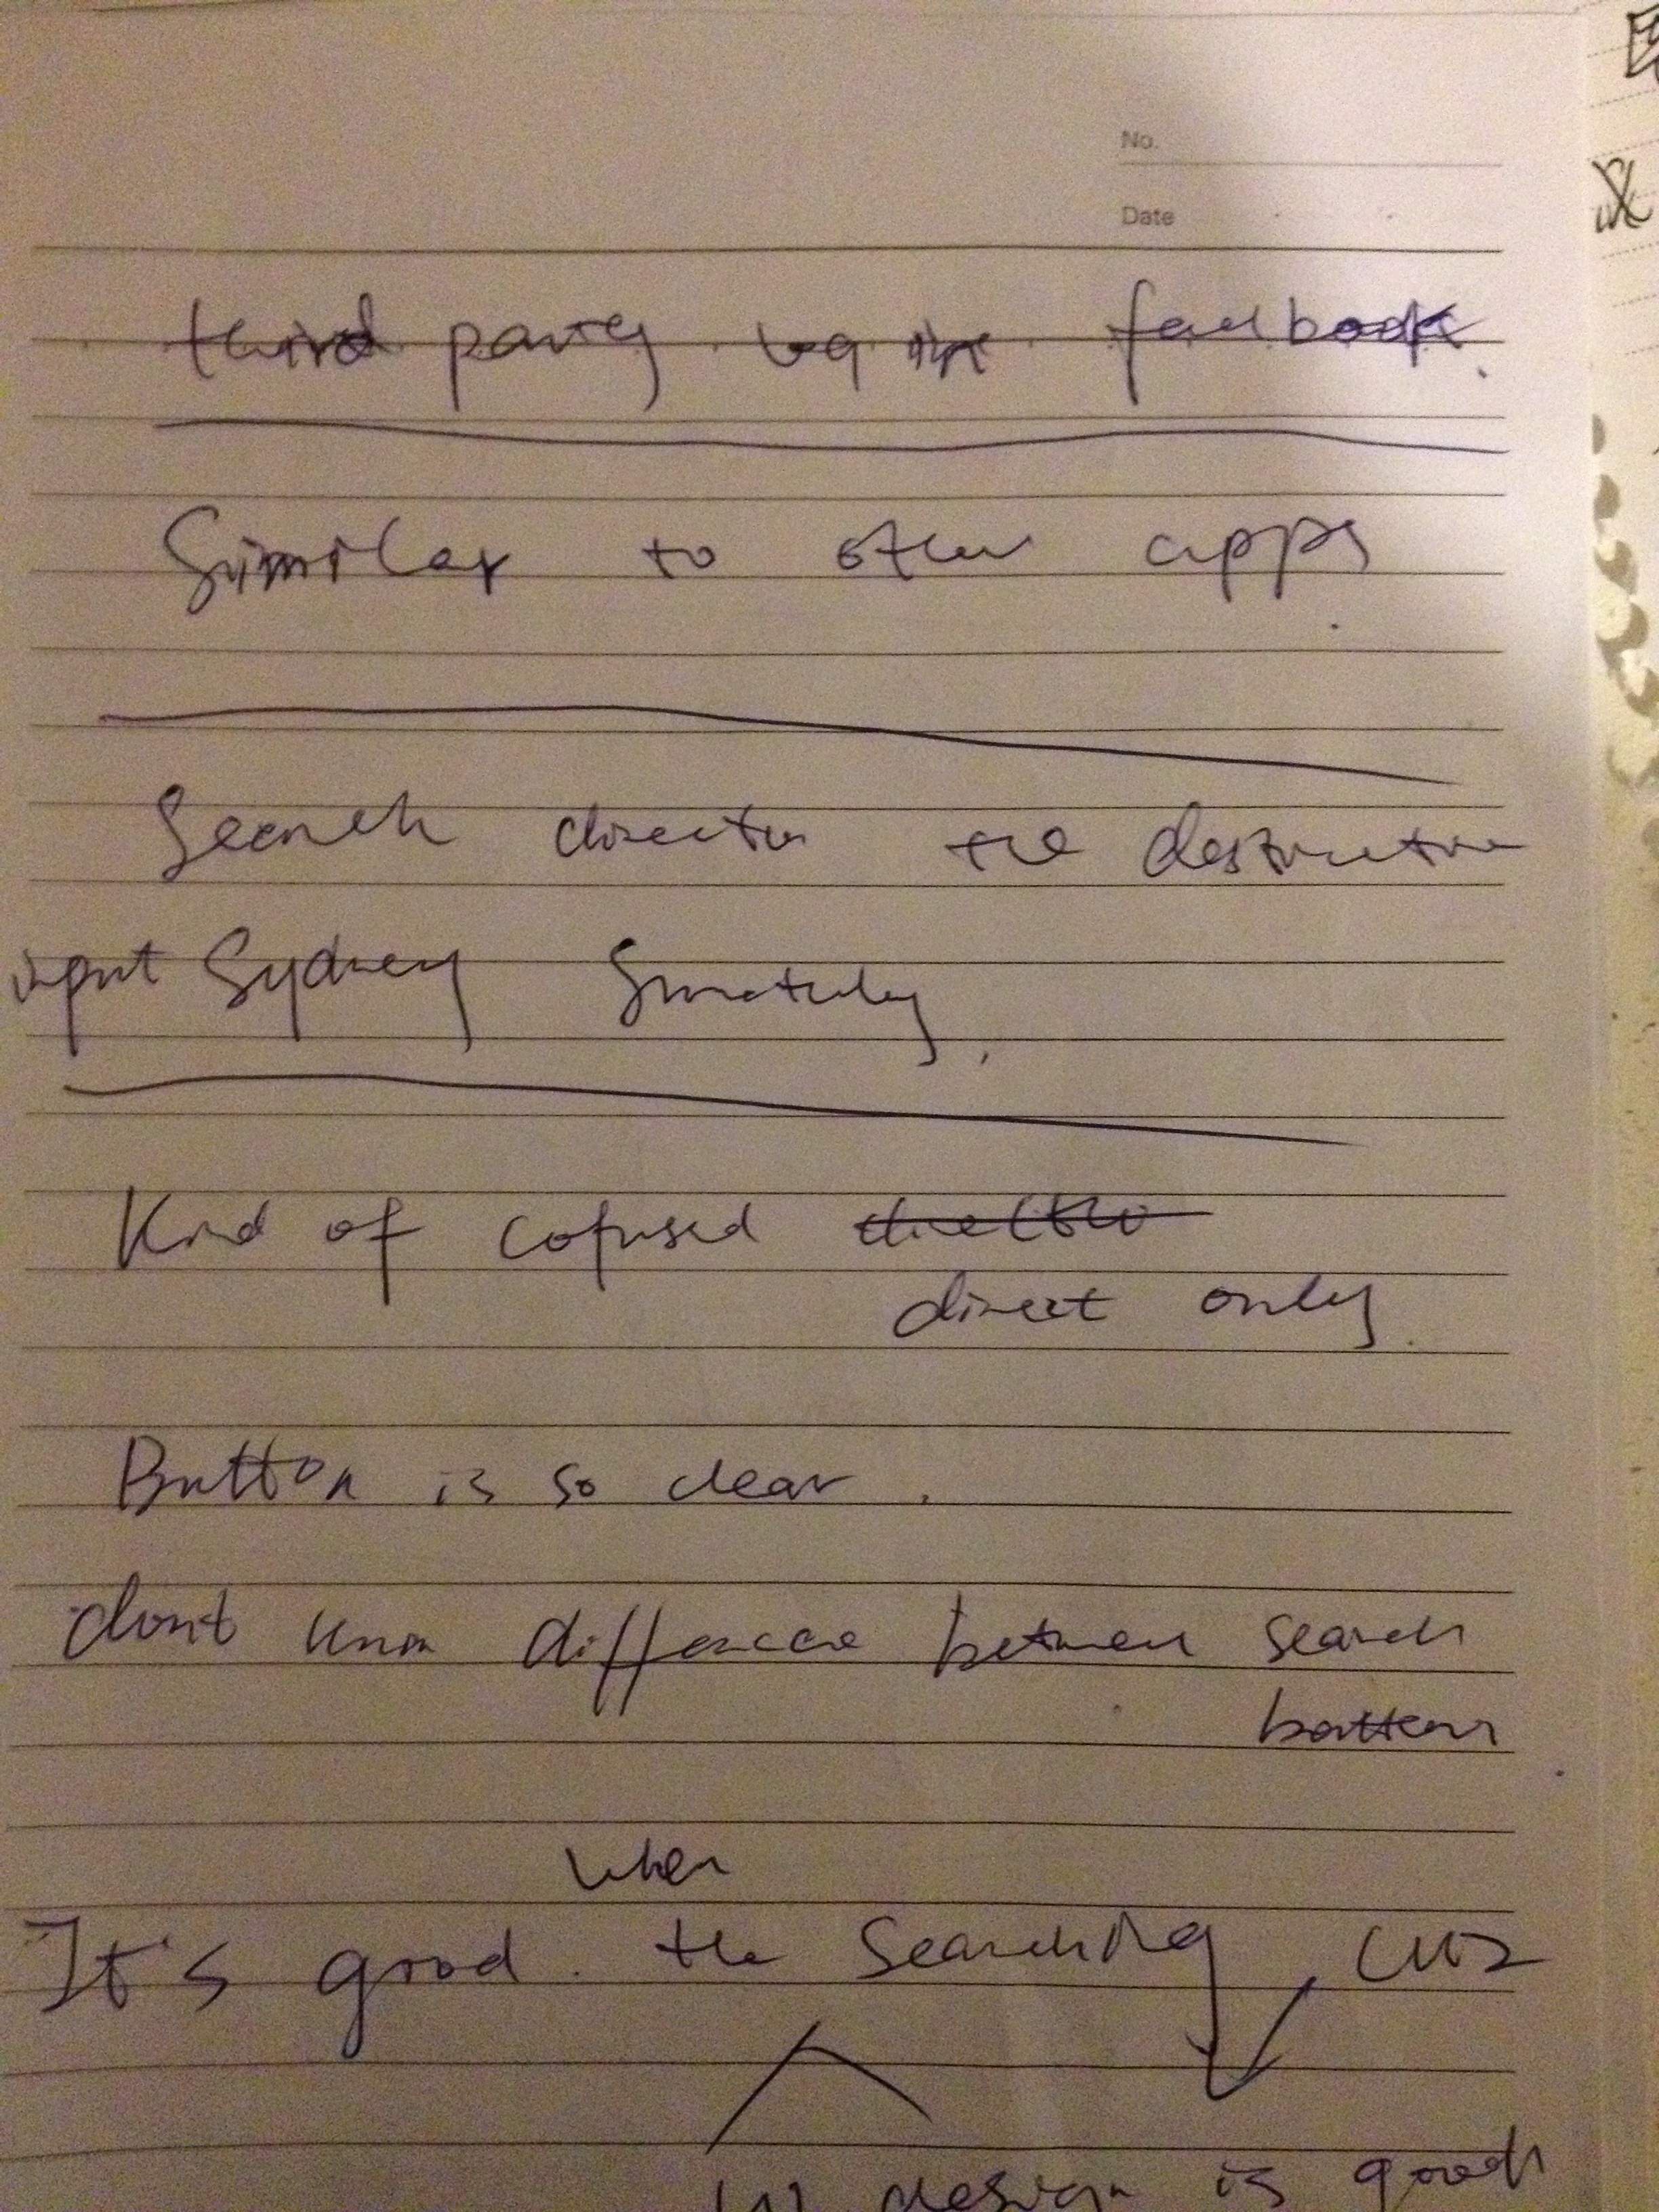

## The App’s Screen Snapshots

|  |  |  |
| --- | --- | --- |
| **No.** | **Snapshot.1** | **Snapshot.2** |
| 1 |  |  |
| 2 | **The third party web site** | **The third party web site** |
| 3 | **iPhone Registration Window** | **Android Registration Window** |
| 4 | **Android has only one Search Button, the layout is not the same as iPhone** | **iPhone has a confusing Explore Button** |
| 5 |  |  |
| 6 |  |  |
| 7 |  |  |
| 8 |  |  |
| 9 |  |  |